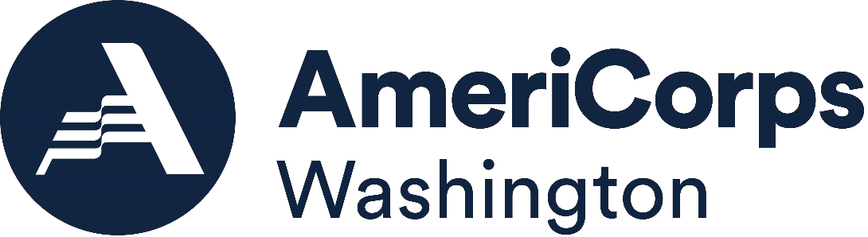

# AmeriCorps State Formula Grant Federal Fiscal Year 2025

**Important Dates**

|  |  |
| --- | --- |
| Request for Grant Applications Released | February 11, 2025 |
| Technical Assistance Zoom for Potential Applicants  **New/Recompete:** [**Join Online Here**](https://ofm-wa-gov.zoom.us/j/88455646707?pwd=8bideWEQCjmsqK0Z5Ha2wEjwaS7FD2.1)  **Continuation:**  [**Join Online Here**](https://ofm-wa-gov.zoom.us/j/81559462675?pwd=DaAIDJROqd2bbwLyiZQ3aOBPPMYxTk.1) | February 18, 2025  **9:00am PST**  **10:15am PST** |
| **Completed Applications Due from Applicants** | **March 28, 2025 by 5:00pm PST** |
| Staff Review for Compliance | March 31, 2025 |
| Grant Review Committee Application Review | March 31 – April 16, 2025 |
| Grant Review Committee Meeting  **Note: Applicants must be available by phone on this day in the event the GRC needs additional information or clarification. Interviews will not be conducted.** | April 17, 2025 |
| Clarification/Revision Period for Some Applicants | Beginning On/Around  April 17, 2025 |
| Serve Washington Commissioners Vote on Grant Review Committee Recommendation | April 24, 2025 |
| Notification to Applicants Regarding Serve Washington Vote | Week of April 28, 2025 |
| Serve Washington to submit applications to AmeriCorps (No Later Than) | May 17, 2025 |
| AmeriCorps to Award Grants (No Later Than) | July 2025 |